Food and drinks in the United Kingdom

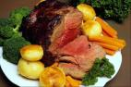

English traditional food is based on beef, lamb, pork, chicken and fish. It’s generally served with potatoes and one other vegetable.

First of all, let’s talk about meals and meal times.

At what time do English people have...
... breakfast? | ... lunch? | ... dinner?

Now explain...

What’s a typical English...
... breakfast? | ... lunch? | ... dinner?

Take-away meals are very popular in the United Kingdom. Which is the classic English take-away food?

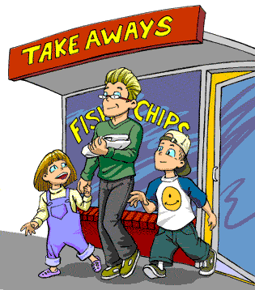
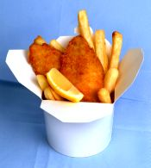
Explain what it is:

Finally, let’s talk about drink. Which is the national drink of the United Kingdom?
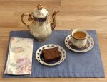
Explain the traditional way of making tea:

What’s the meanning of “I want a cuppa”?

It means

