What language do they speak in the United Kingdom?

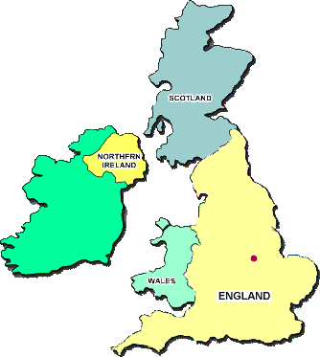

English, of course! The main language spoken in Britain is English, although other languages are spoken too.

⬥ People in Wales speak a different language . It’s called
⬥ People in Scotland speak a different language. It’s called
⬥ People in Northern Ireland speak a different language . It’s called

How do you say “How are you?” in...
Gaelic?

Irish?

Welsh?

