What currency do they use in the United Kingdom?

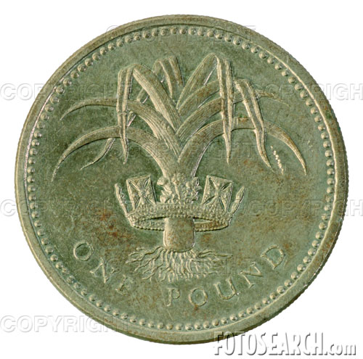
The currency used is the pound sterling. The symbol for the pound is £ . The pound (£) is made up of 100 pence (p) exactly as the euro is split into 100 cents.

How much is a pound worth in euros?

1 £ = euros

There are banknotes and coins

Banknotes
 | What colour is it? | It features...

5 £

10 £

20 £

50 £

What sort of coins are there?

How much do things cost in the United Kingdom? (estimated)
Item | Cost (pounds £) | Equivalent (euros €) | Cost in Spain (€)
Milk (4 pints) | 1.11 £
Bread (400g loaf) | 0.75 £
Eggs (carton of 6) | 0.98 £
Sugar (750g) | 0.79 £
Can of Pepsi | 0.60 £
Meal in a restaurant | From 8.00 £
McDonalds Meal | 3.50 £
Cinema Ticket | 7.50 adult
Do you think the United Kingdom is a cheap place to live?

