The Royal Family

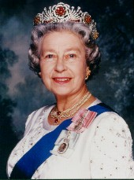

The Queen

Name:
Date of birth:
What is her husband’s name?
What are her sons’ names?
What are her daughters’ names?

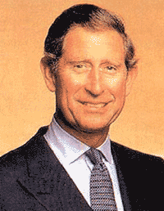

The Prince of Wales: He’s is the Queen’s oldest son. He will be the next King

Name:
Date of birth:
What is his wife’s name?
What are his sons’ names?
Who was his first wife?

Who are they?

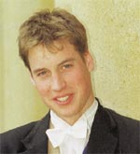

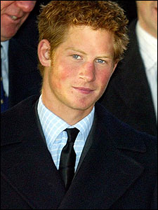

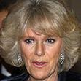

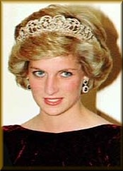

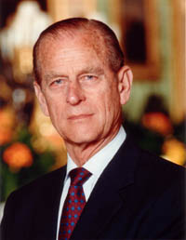

The Royal Family tree

