Education

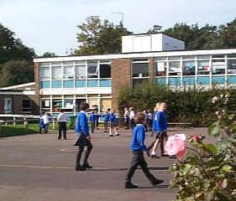

Education is an important part of British life. There are hundreds of schools, colleges and universities, including some of the most famous ones in the world.

At what age do children start school in England?
On what days do children attend school?
At what time do they have lunch in school?
What do children have for lunch at school?
Do children in England wear a school uniform?

Boys wear.... | Girls wear...

