Shopping in the United Kingdom

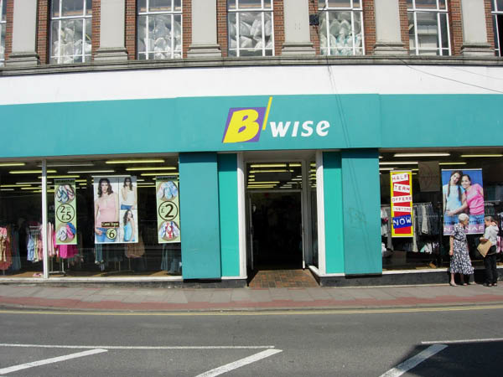

British people love to shop! London alone has over 40,000 shops and 26 major street markets to choose from.

First of all, at what time do shops open in the United Kingdom?

Monday | Tuesday | Wednesday | Thursday | Friday | Saturday | Sunday

Let’s go shopping in London! What can you find in...

Major Streets Markets
Oxford Street
Covent Garden
Totteham Court Road
Knightsbridge

Famous stores
Harrods
Selfridges
Hamley

London Markets
Petticoat Lane Market
Portobello Market
Camden Market

Now, imagine you are in London. If you had 10 pounds to spend on presents for your friends and family back home, what would you buy and who for?

(Do this activity on a new document. Write a proper title and copy and paste the pictures. Write the name of the present and who it is for. Print it)

