La Major Mi Major Re Major Do Major
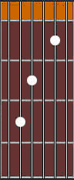
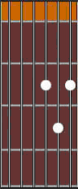
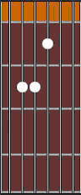
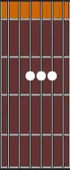

Sol Major Fa Major Si Major
