Written methods for addition of whole numbers
The aim is that children use mental methods when appropriate, but for calculations that they cannot do in their heads they use an efficient written method accurately and with confidence. Children are entitled to be taught and to acquire secure mental methods of calculation and one efficient written method of calculation for addition which they know they can rely on when mental methods are not appropriate. These notes show the stages in building up to using an efficient written method for addition of whole numbers by the end of Year 4.

To add successfully, children need to be able to:
- recall all addition pairs to 9 + 9 and complements in 10;
- add mentally a series of one-digit numbers, such as 5 + 8 + 4;
- add multiples of 10 (such as 60 + 70) or of 100 (such as 600 + 700) using the related addition fact, 6 + 7, and their knowledge of place value;
- partition two-digit and three-digit numbers into multiples of 100, 10 and 1 in different ways.

Note: It is important that children’s mental methods of calculation are practised and secured alongside their learning and use of an efficient written method for addition.

Stage 1: The empty number line
- The mental methods that lead to column addition generally involve partitioning, e.g. adding the tens and ones separately, often starting with the tens. Children need to be able to partition numbers in ways other than into tens and ones to help them make multiples of ten by adding in steps.  - The empty number line helps to record the steps on the way to calculating the total. | Steps in addition can be recorded on a number line. The steps often bridge through a multiple of 10.  8 + 7 = 15  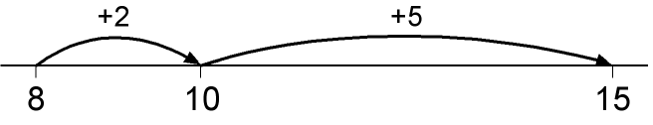  48 + 36 = 84  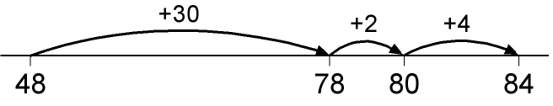  or:  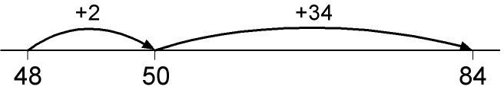
Stage 2: Partitioning
- The next stage is to record mental methods using partitioning. Add the tens and then the ones to form partial sums and then add these partial sums.  - Partitioning both numbers into tens and ones mirrors the column method where ones are placed under ones and tens under tens. This also links to mental methods. | Record steps in addition using partitioning:  47 + 76 = 47 + 70 + 6 = 117 + 6 = 123  47 + 76 = 40 + 70 + 7 + 6 = 110 + 13 = 123  Partitioned numbers are then written under one another:

Stage 3: Expanded method in columns
- Move on to a layout showing the addition of the tens to the tens and the ones to the ones separately. To find the partial sums either the tens or the ones can be added first, and the total of the partial sums can be found by adding them in any order. As children gain confidence, ask them to start by adding the ones digits first always.  - The addition of the tens in the calculation 47 + 76 is described in the words ‘forty plus seventy equals one hundred and ten’, stressing the link to the related fact ‘four plus seven equals eleven’.  - The expanded method leads children to the more compact method so that they understand its structure and efficiency. The amount of time that should be spent teaching and practising the expanded method will depend on how secure the children are in their recall of number facts and in their understanding of place value. | Write the numbers in columns.  Adding the tens first:  Adding the ones first:  Discuss how adding the ones first gives the same answer as adding the tens first. Refine over time to adding the ones digits first consistently.
Stage 4: Column method
- In this method, recording is reduced further. Carry digits are recorded below the line, using the words ‘carry ten’ or ‘carry one hundred’, not ‘carry one’.  - Later, extend to adding three two-digit numbers, two three-digit numbers and numbers with different numbers of digits. | Column addition remains efficient when used with larger whole numbers and decimals. Once learned, the method is quick and reliable.

Written methods for subtraction of whole numbers
The aim is that children use mental methods when appropriate, but for calculations that they cannot do in their heads they use an efficient written method accurately and with confidence. Children are entitled to be taught and to acquire secure mental methods of calculation and one efficient written method of calculation for subtraction which they know they can rely on when mental methods are not appropriate.
These notes show the stages in building up to using an efficient method for subtraction of two-digit and three-digit whole numbers by the end of Year 4.

To subtract successfully, children need to be able to:
- recall all addition and subtraction facts to 20;
- subtract multiples of 10 (such as 160 – 70) using the related subtraction fact,16 – 7, and their knowledge of place value;
- partition two-digit and three-digit numbers into multiples of one hundred, ten and one in different ways (e.g. partition 74 into 70 + 4 or 60 + 14).

Note: It is important that children’s mental methods of calculation are practised and secured alongside their learning and use of an efficient written method for subtraction.

Stage 1: Using the empty number line
- The empty number line helps to record or explain the steps in mental subtraction. A calculation like 74 – 27 can be recorded by counting back 27 from 74 to reach 47. The empty number line is also a useful way of modelling processes such as bridging through a multiple of ten.  - The steps can also be recorded by counting up from the smaller to the larger number to find the difference, for example by counting up from 27 to 74 in steps totalling 47.  - With practice, children will need to record less information and decide whether to count back or forward. It is useful to ask children whether counting up or back is the more efficient for calculations such as 57 – 12, 86 – 77 or 43 – 28.  - The notes below give more detail on the counting-up method using an empty number line. | Steps in subtraction can be recorded on a number line. The steps often bridge through a multiple of 10.  15 – 7 = 8  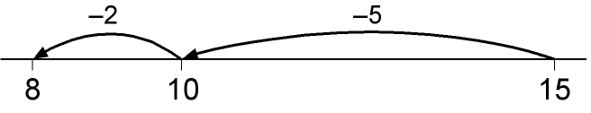  74 – 27 = 47 worked by counting back:  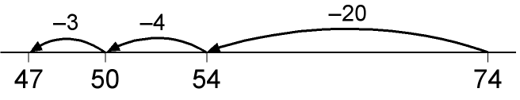  The steps may be recorded in a different order:  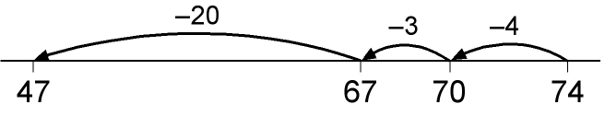  or combined:  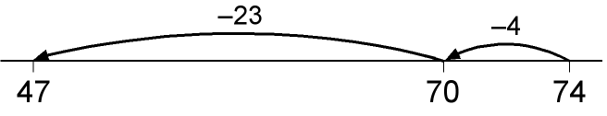
The counting-up method
- The mental method of counting up from the smaller to the larger number can be recorded using either number lines or vertically in columns. The number of rows (or steps) can be reduced by combining steps. With two-digit numbers, this requires children to be able to work out the answer to a calculation such as 30 + £ = 74 mentally. | 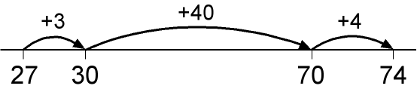  or:  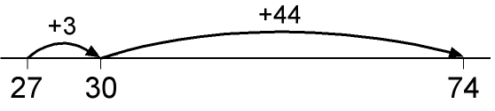
- With three-digit numbers the number of steps can again be reduced, provided that children are able to work out answers to calculations such as 178 + £ = 200 and 200 + £ = 326 mentally.  - The most compact form of recording remains reasonably efficient. | 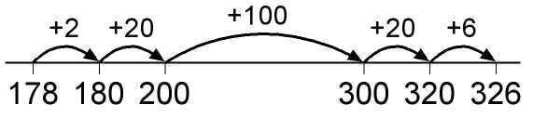  or:  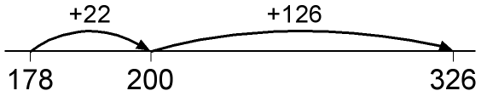
- The method can be used with decimals where no more than three columns are required. However, it becomes less efficient when more than three columns are needed.  - This counting-up method can be a useful alternative for children whose progress is slow, whose mental and written calculation skills are weak and whose projected attainment at the end of Key Stage 2 is towards the lower end of level 4. | 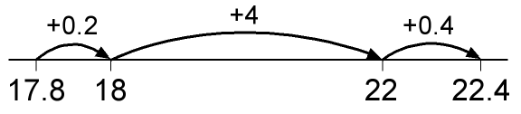  or:  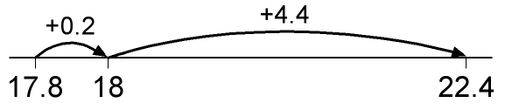
Stage 2: Partitioning
- Subtraction can be recorded using partitioning to write equivalent calculations that can be carried out mentally. For  74 – 27 this involves partitioning the 27 into 20 and 7, and then subtracting from 74 the 20 and the 4 in turn. Some children may need to partition the 74 into 70 + 4 or 60 + 14 to help them carry out the subtraction. | Subtraction can be recorded using partitioning:  74 – 27 = 74 – 20 – 7 = 54 – 7 = 47  74 – 27 = 70 + 4 – 20 – 7 = 60 + 14 – 20 – 7 = 40 + 7  This requires children to subtract a single-digit number or a multiple of 10 from a two-digit number mentally. The method of recording links to counting back on the number line.
Stage 3: Expanded layout, leading to column method
- Partitioning the numbers into tens and ones and writing one under the other mirrors the column method, where ones are placed under ones and tens under tens.  - This does not link directly to mental methods of counting back or up but parallels the partitioning method for addition. It also relies on secure mental skills.  - The expanded method leads children to the more compact method so that they understand its structure and efficiency. The amount of time that should be spent teaching and practising the expanded method will depend on how secure the children are in their recall of number facts and with partitioning. | Partitioned numbers are then written under one another:  Example: 74 − 27  Example: 741 − 367

The expanded method for three-digit numbers
Example: 563 − 241, no adjustment or decomposition needed
Expanded method leading to
Start by subtracting the ones, then the tens, then the hundreds. Refer to subtracting the tens, for example, by saying ‘sixty take away forty’, not ‘six take away four’.
Example: 563 − 271, adjustment from the hundreds to the tens, or partitioning the hundreds
Begin by reading aloud the number from which we are subtracting: ‘five hundred and sixty-three’. Then discuss the hundreds, tens and ones components of the number, and how 500 + 60 can be partitioned into 400 + 160. The subtraction of the tens becomes ‘160 minus 70’, an application of subtraction of multiples of ten.
Example: 563 − 278, adjustment from the hundreds to the tens and the tens to the ones
Here both the tens and the ones digits to be subtracted are bigger than both the tens and the ones digits you are subtracting from. Discuss how 60 + 3 is partitioned into 50 + 13, and then how 500 + 50 can be partitioned into 400 + 150, and how this helps when subtracting.
Example: 503 − 278, dealing with zeros when adjusting
Here 0 acts as a place holder for the tens. The adjustment has to be done in two stages. First the 500 + 0 is partitioned into 400 + 100 and then the 100 + 3 is partitioned into 90 + 13.

Written methods for multiplication of whole numbers

The aim is that children use mental methods when appropriate, but for calculations that they cannot do in their heads they use an efficient written method accurately and with confidence. Children are entitled to be taught and to acquire secure mental methods of calculation and one efficient written method of calculation for multiplication which they know they can rely on when mental methods are not appropriate.

These notes show the stages in building up to using an efficient method for two-digit by one-digit multiplication by the end of Year 4, two-digit by two-digit multiplication by the end of Year 5, and three-digit by two-digit multiplication by the end of Year 6.

To multiply successfully, children need to be able to:
- recall all multiplication facts to 10 × 10;
- partition number into multiples of one hundred, ten and one;
- work out products such as 70 × 5, 70 × 50, 700 × 5 or 700 × 50 using the related fact 7 × 5 and their knowledge of place value;
- add two or more single-digit numbers mentally;
- add multiples of 10 (such as 60 + 70) or of 100 (such as 600 + 700) using the related addition fact, 6 + 7, and their knowledge of place value;
- add combinations of whole numbers using the column method (see above).

Note: It is important that children’s mental methods of calculation are practised and secured alongside their learning and use of an efficient written method for multiplication.

Stage 1: Mental multiplication using partitioning
- Mental methods for multiplying TU × U can be based on the distributive law of multiplication over addition. This allows the tens and ones to be multiplied separately to form partial products. These are then added to find the total product. Either the tens or the ones can be multiplied first but it is more common to start with the tens. | Informal recording in Year 4 might be:  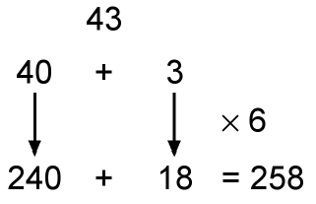  Also record mental multiplication using partitioning:  Note: These methods are based on the distributive law. Children should be introduced to the principle of this law (not its name) in Years 2 and 3, for example when they use their knowledge of the 2, 5 and 10 times-tables to work out multiples of 7:  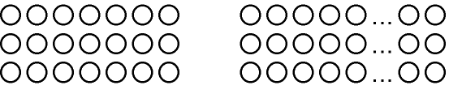

Stage 2: The grid method
- As a staging post, an expanded method which uses a grid can be used. This is based on the distributive law and links directly to the mental method. It is an alternative way of recording the same steps.  - It is better to place the number with the most digits in the left-hand column of the grid so that it is easier to add the partial products. | 38 × 7 = (30 × 7) + (8 × 7) = 210 + 56 = 266  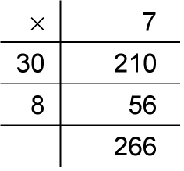
- The next step is to move the number being multiplied (38 in the example shown) to an extra row at the top. Presenting the grid this way helps children to set out the addition of the partial products 210 and 56.  - The grid method may be the main method used by children whose progress is slow, whose mental and written calculation skills are weak and whose projected attainment at the end of Key Stage 2 is towards the lower end of level 4. | 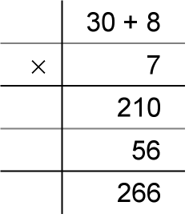
Stage 3: Expanded short multiplication
- The next step is to represent the method of recording in a column format, but showing the working. Draw attention to the links with the grid method above.
- Children should describe what they do by referring to the actual values of the digits in the columns. For example, the first step in 38 × 7 is ‘thirty multiplied by seven’, not ‘three times seven’, although the relationship 3 × 7 should be stressed.
- Most children should be able to use this expanded method for TU × U by the end of Year 4.
Stage 4: Short multiplication
- The recording is reduced further, with carry digits recorded below the line.  - If, after practice, children cannot use the compact method without making errors, they should return to the expanded format of stage 3. | The step here involves adding 210 and 50 mentally with only the 5 in the 50 recorded. This highlights the need for children to be able to add a multiple of 10 to a two-digit or three-digit number mentally before they reach this stage.

Stage 5: Two-digit by two-digit products
- Extend to TU × TU, asking children to estimate first.  - Start with the grid method. The partial products in each row are added, and then the two sums at the end of each row are added to find the total product.  - As in the grid method for TU × U in stage 4, the first column can become an extra top row as a stepping stone to the method below. | 56 × 27 is approximately 60 × 30 = 1800.  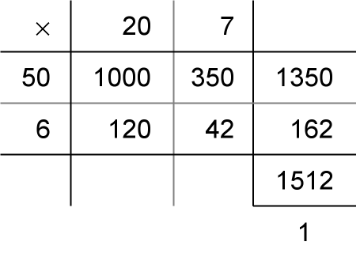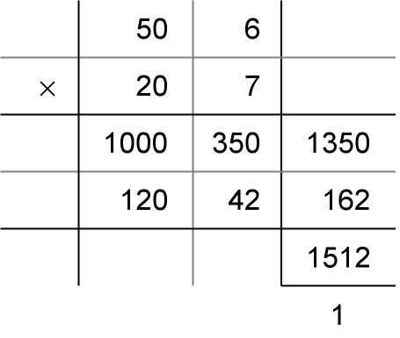
- Reduce the recording, showing the links to the grid method above. | 56 × 27 is approximately 60 × 30 = 1800.
- Reduce the recording further.  - The carry digits in the partial products of 56 × 20 = 120 and 56 × 7 = 392 are usually carried mentally.  - The aim is for most children to use this long multiplication method for TU × TU by the end of Year 5. | 56 × 27 is approximately 60 × 30 = 1800.

Stage 6: Three-digit by two-digit products
- Extend to HTU × TU asking children to estimate first. Start with the grid method.  - It is better to place the number with the most digits in the left-hand column of the grid so that it is easier to add the partial products. | 286 × 29 is approximately 300 × 30 = 9000.  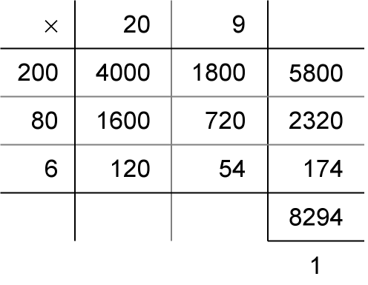
- Reduce the recording, showing the links to the grid method above.
- This expanded method is cumbersome, with six multiplications and a lengthy addition of numbers with different numbers of digits to be carried out. There is plenty of incentive to move on to a more efficient method.
- Children who are already secure with multiplication for TU × U and TU × TU should have little difficulty in using the same method for HTU × TU.  - Again, the carry digits in the partial products are usually carried mentally. | 286 × 29 is approximately 300 × 30 = 9000.

Written methods for division of whole numbers

The aim is that children use mental methods when appropriate, but for calculations that they cannot do in their heads they use an efficient written method accurately and with confidence. Children are entitled to be taught and to acquire secure mental methods of calculation and one efficient written method of calculation for division which they know they can rely on when mental methods are not appropriate.

These notes show the stages in building up to long division through Years 4 to 6 – first long division TU ÷ U, extending to HTU ÷ U, then HTU ÷ TU, and then short division HTU ÷ U.

To divide successfully in their heads, children need to be able to:
- understand and use the vocabulary of division – for example in 18 ÷ 3 = 6, the 18 is the dividend, the 3 is the divisor and the 6 is the quotient;
- partition two-digit and three-digit numbers into multiples of 100, 10 and 1 in different ways;
- recall multiplication and division facts to 10 × 10, recognise multiples of one-digit numbers and divide multiples of 10 or 100 by a single-digit number using their knowledge of division facts and place value;
- know how to find a remainder working mentally – for example, find the remainder when 48 is divided by 5;
- understand and use multiplication and division as inverse operations.

Note: It is important that children’s mental methods of calculation are practised and secured alongside their learning and use of an efficient written method for division.

To carry out written methods of division successful, children also need to be able to:
- understand division as repeated subtraction;
- estimate how many times one number divides into another – for example, how many sixes there are in 47, or how many 23s there are in 92;
- multiply a two-digit number by a single-digit number mentally;
- subtract numbers using the column method.

Stage 1: Mental division using partitioning
- Mental methods for dividing TU ÷ U can be based on partitioning and on the distributive law of division over addition. This allows a multiple of the divisor and the remaining number to be divided separately. The results are then added to find the total quotient.  - Many children can partition and multiply with confidence. But this is not the case for division. One reason for this may be that mental methods of division, stressing the correspondence to mental methods of multiplication, have not in the past been given enough attention.  - Children should also be able to find a remainder mentally, for example the remainder when 34 is divided by 6. | One way to work out TU ÷ U mentally is to partition TU into a multiple of the divisor plus the remaining ones, then divide each part separately.  Informal recording in Year 4 for 84 ÷ 7 might be:  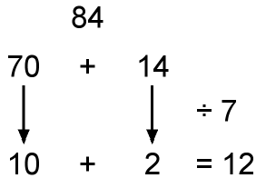  In this example, using knowledge of multiples, the 84 is partitioned into 70 (the highest multiple of 7 that is also a multiple of 10 and less than 84) plus 14 and then each part is divided separately using the distributive law.  Another way to record is in a grid, with links to the grid method of multiplication.  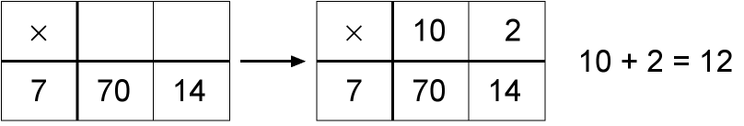  As the mental method is recorded, ask: ‘How many sevens in seventy?’ and: ‘How many sevens in fourteen?’  Also record mental division using partitioning:  Remainders after division can be recorded similarly.

Stage 2: Short division of TU ÷ U
- ‘Short’ division of TU ÷ U can be introduced as a more compact recording of the mental method of partitioning.  - Short division of a two-digit number can be introduced to children who are confident with multiplication and division facts and with subtracting multiples of 10 mentally, and whose understanding of partitioning and place value is sound.  - For most children this will be at the end of Year 4 or the beginning of Year 5.  - The accompanying patter is ‘How many threes divide into 80 so that the answer is a multiple of 10?’ This gives 20 threes or 60, with 20 remaining. We now ask: ‘What is 21divided by three?’ which gives the answer 7. | For 81 ÷ 3, the dividend of 81 is split into 60, the highest multiple of 3 that is also a multiple 10 and less than 81, to give 60 + 21. Each number is then divided by 3.  The short division method is recorded like this:  This is then shortened to:  The carry digit ‘2’ represents the 2 tens that have been exchanged for 20 ones. In the first recording above it is written in front of the 1 to show that 21 is to be divided by 3. In second it is written as a superscript.  The 27 written above the line represents the answer: 20 + 7, or 2 tens and 7 ones.

Stage 3: ‘Expanded’ method for HTU ÷ U
- This method is based on subtracting multiples of the divisor from the number to be divided, the dividend.  - For TU ÷ U there is a link to the mental method.  - As you record the division, ask: ‘How many nines in 90?’ or ‘What is 90 divided by 9?’  - Once they understand and can apply the method, children should be able to move on from TU ÷ U to HTU ÷ U quite quickly as the principles are the same.  - This method, often referred to as ‘chunking’, is based on subtracting multiples of the divisor, or ‘chunks’. Initially children subtract several chunks, but with practice they should look for the biggest multiples of the divisor that they can find to subtract.  - Chunking is useful for reminding children of the link between division and repeated subtraction.  - However, children need to recognise that chunking is inefficient if too many subtractions have to be carried out. Encourage them to reduce the number of steps and move them on quickly to finding the largest possible multiples. | 97 ÷ 9
- The key to the efficiency of chunking lies in the estimate that is made before the chunking starts. Estimating for HTU ÷ U involves multiplying the divisor by multiples of 10 to find the two multiples that ‘trap’ the HTU dividend.  - Estimating has two purposes when doing a division:  - to help to choose a starting point for the division;  - to check the answer after the calculation.  - Children who have a secure knowledge of multiplication facts and place value should be able to move on quickly to the more efficient recording on the right. | To find 196 ÷ 6, we start by multiplying 6 by 10, 20, 30, … to find that 6 × 30 = 180 and 6 × 40 = 240. The multiples of 180 and 240 trap the number 196. This tells us that the answer to 196 ÷ 6 is between 30 and 40.  Start the division by first subtracting 180, leaving 16, and then subtracting the largest possible multiple of 6, which is 12, leaving 4.  The quotient 32 (with a remainder of 4) lies between 30 and 40, as predicted.

Stage 4: Short division of HTU ÷ U
- ‘Short’ division of HTU ÷ U can be introduced as an alternative, more compact recording. No chunking is involved since the links are to partitioning, not repeated subtraction.  - The accompanying patter is ‘How many threes in 290?’ (the answer must be a multiple of 10). This gives 90 threes or 270, with 20 remaining. We now ask: ’How many threes in 21?’ which has the answer 7.  - Short division of a three-digit number can be introduced to children who are confident with multiplication and division facts and with subtracting multiples of 10 mentally, and whose understanding of partitioning and place value is sound.  - For most children this will be at the end of Year 5 or the beginning of Year 6. | For 291 ÷ 3, because 3 × 90 = 270 and 3 × 100 = 300, we use 270 and split the dividend of 291 into 270 + 21. Each part is then divided by 3.  The short division method is recorded like this:  This is then shortened to:  The carry digit ‘2’ represents the 2 tens that have been exchanged for 20 ones. In the first recording above it is written in front of the 1 to show that a total of 21 ones are to be divided by 3.  The 97 written above the line represents the answer: 90 + 7, or 9 tens and 7 ones.
Stage 5: Long division
- The next step is to tackle HTU ÷ TU, which for most children will be in Year 6.  - The layout on the right, which links to chunking, is in essence the ‘long division’ method. Recording the build-up to the quotient on the left of the calculation keeps the links with ‘chunking’ and reduces the errors that tend to occur with the positioning of the first digit of the quotient.  - Conventionally the 20, or 2 tens, and the 3 ones forming the answer are recorded above the line, as in the second recording. | How many packs of 24 can we make from 560 biscuits? Start by multiplying 24 by multiples of 10 to get an estimate. As 24 × 20 = 480 and 24 × 30 = 720, we know the answer lies between 20 and 30 packs. We start by subtracting 480 from 560.  In effect, the recording above is the long division method, though conventionally the digits of the answer are recorded above the line as shown below.

