Vocabulary UNIT 1 LESSON 1 / PARALLEL AND PERPENDICULAR LINES

Parallel lines
Lines that never cross and are always the same distance apart
Perpendicular lines
Two lines that intersect to form four right angles
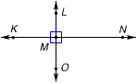
Right-angle
An angle that forms a square corner and measures 90°
