Vocabulary UNIT 1 LESSON 2
parallel and perpendicular
Angle  A figure formed by two rays that meet at a common endpoint  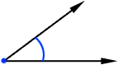 | Bisect  To divide into two equal parts  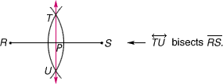 | Degree  A unit for measuring angles and temperatura.  Diagram  A diagram is a simplified and structured visual representation of concepts, ideas, constructions, relations, etc used to visualize and clarify the topic.

