VOCABULARY UNIT 1 LESSON 3
AROUND AND AROUND
Doubles  When both numbers that are added are the same number.  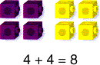  Digit  Simbol used to show a number.  0ne-digit number 7  Two- digit number 65  Length  Distance from one end to the other. How long is something.  Circumference  The distance around a circle.  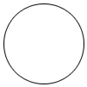  C = d  Radius  The distance from a center point of a circle to its circumference.  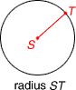 | Half / Haves  One of two equal parts.  1 half + 1 half = 1 whole  2 halves = 1 whole  Odd numbers  Odd numbers do not make pairs.    7 is an odd number.  Circle    Diameter  A line that passes through the center of a circle  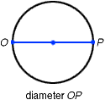  Calculator  A resource to do mathematical operations  