VOCABULARY UNIT 1 LESSON 4
CIRCLE DISIGN
Corner  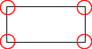  This figure has 4 corners  Semi-circle  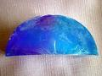  Half of a circle | Square    A figure with four equal sides  Centimeter (cm)  A unit of measurement  100 centimeters = 1 meter

