Vocabulary UNIT 1 LESSON 6
CALCULATION ANGLES
Vocabulary related to angles | OTHER VOCABULARY
Acute angle  An angle that measures less than a right angle (90°).  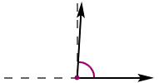  Obtuse angle  An angle whose measure is greater than 90° and less than 180°.  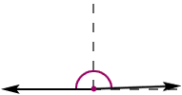  Right angle  An angle that forms a square corner and measures 90°  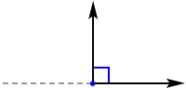  Straight angle  An angle whose measure is 180°  Degree  A unit for measuring angles and temperature  Complementary angles  Two angles whose measures have a sum of 90°  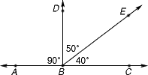  DBE and EBC are complementary.  Adjacent angles  Angles that share a common side, have the same vertex , and do not overlap.  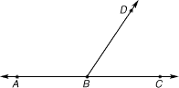  ABD is adjacent to DBC. | Factor or number fact  A number that is multiplied by another number to find a product  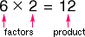  The factors are 6 and 2.  Multiple  A number that is the product of a given number and a whole number  To find the multiples of any number, multiply the number by the counting numbers 1, 2, 3, 4, and so on. The first six multiples of 3 are shown below in red.  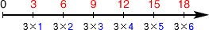  Rotation (turn)  A turning of a figure about a fixed point  Estimate  An answer that is close to the exact answer.  Split pin  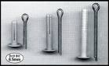  Strips  