Vocabulary UNIT 3 LESSON 1
SYMMETRY
Line of symmetry  A line that divides a figure so that the two parts of the figure are congruent (equal)  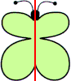 | Reflective symmetry  When one half of a figure looks like the mirror image of the other half  