Vocabulary UNIT 3 LESSON 2
FOLDING PAPER
Mirror  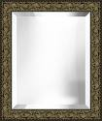  Pattern  A repeat design | Reflection  A mirror view    Silk paper  d

